Foundation for Youth Awakening and Empowerment (FOYAE)
Gyara Kayanka; Amana Initiative project 2.0 Final report. September, 2016.
Activities: Stakeholders Forum, Airing of Hausa peace-building Drama, Monthly Peace Road walk, Policy Dialogue, Live media
chat, Peace sports competition, `Dine with a cop` peace dinner.

Project Team re-orientation Meeting
Foundation for Youth awakening and Empowerment kick started its project implementation with a project team reorientation in the first week of May, precisely on Thursday, 5th May, 2016. A total of six (6) persons (3 project team members and three other FOYAE staff) were in attendance. The purpose of this activity was to keep the project team members abreast of the Gyara Kayanka - the Amana Initiative 2.0 project especially the project thrust. Also, to re-define specific roles and responsibilities as well as expectations from each of project team member for a more effective result based project implementation. At the end of the orientation exercise, there was an increased understanding of the project thrust among team members, a more coordinated official interaction among team members, and project team members were more motivated and committed to achieving project desired goal.
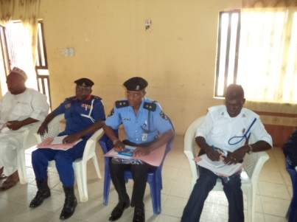
From the left:, ANGO Chairman, Ibrahim Yusuf, Representative of NSCDC, Representative of Nigeria Police and the representative of The Boys Brigade of Nigeria. Photo credit: Cleobas James

Stakeholders’ project inception forum
In week three of the project, precisely on 19th May, 2016, the project held a stakeholders’ forum at Women Development center, Ministry of Women Affairs, Gombe. The event was well attended by 35 stakeholders.
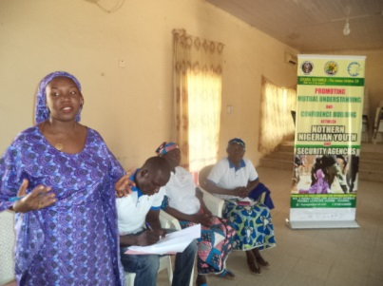Amdo A Mukollo of Care for Life Mission stressing a point durin the stateholders forum. Photo: Cleobas James
The objective of the forum was to abreast stakeholders of the project, adopt strategies and activities to be implemented during the project period, increase mutual understanding among stakeholders and increase awareness and on civic rights and responsibilities of respective stakeholders. Stakeholders bored their minds on the issue of misunderstanding between civilians and security agencies. Many of the stakeholders emphasized the need to say the truth and walk the talking. The entire event was a huge success.

CHALLENGES:
- Sharp changes is prices have affected project implementation because budget could not meet up with actuals.
- Some individuals took advantages of the fora to vent their anger against security agencies.
- Some relevant stakeholders demand for money to carry out some services tight to the project. Such charges had no budget lines.
- Cutting down of the proposed budget with commiserating reduction in the listed activities was also a challenge.
- Unfriendly whether had affected the execution of some project activities and the planned period.
- Untimely release of funds (second tranche).

RECOMMENDATIONS
- Stakeholders have called for longer implementation time frame because of the timeliness and relevance of the project.
- Timely release of funds is will lead to timely completion of project.

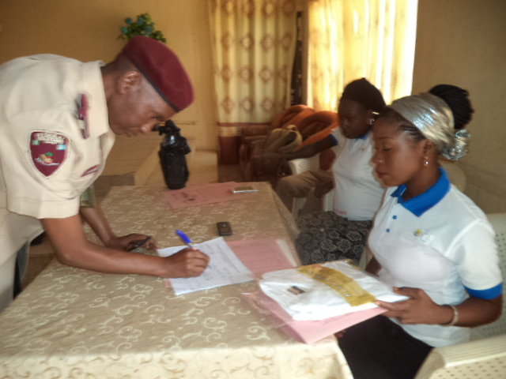
Signing the attendance register during the Statkeholders forum
Photo Credit: Cleobas James

Monthly Road Walk
In the last week May, week four, the first edition of the Gyara Kayanka; Amana Initiative monthly peace road walk kicked off on 28th May, 2016. The objective of this activity is to create an environment for Youth to interact with security personnel as they take a walk together. We believe that as young men walk together (both those in uniform and civilians); there will naturally be an avenue for them to interact. 65 people were in attendance in the first edition including security personnel such as police, DSS, and Civil Defense; youth groups such as Gombe state social agents, Man O’ War, Boys Brigade and National Youth Council; Civil society organizations such as TEMIN, KISHIMI Shelter, and Red Cross of Nigeria.
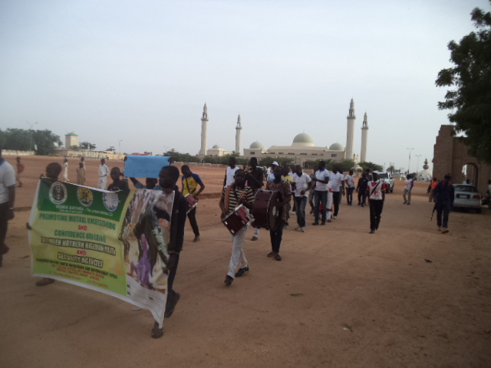
Leaving the Emir’s Palace, road walk still gathering momentum
Photos: Benjamin Maina

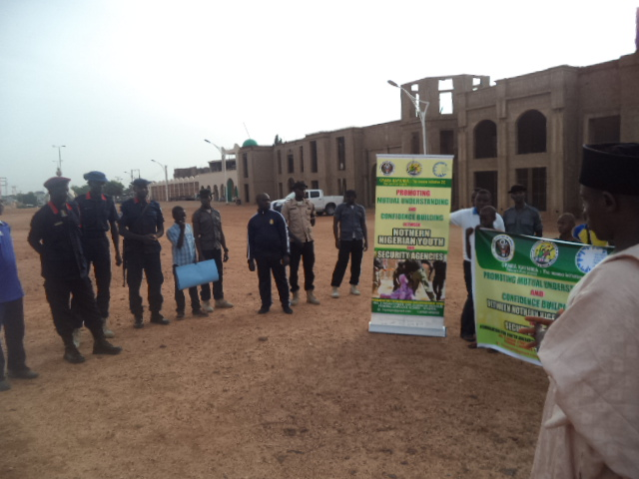
At the Emir of Gombe’s Palace before the commencement of the first road walk.
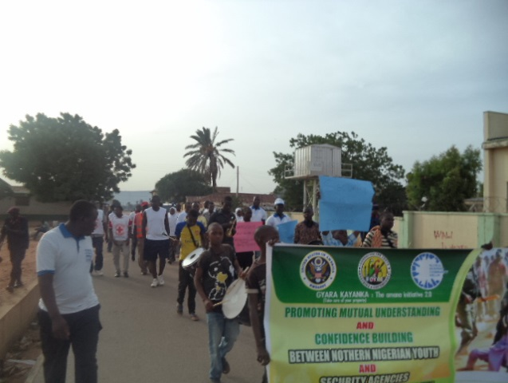
In subsequent editions the number kept growing. Second edition had 78 people in attendance, third 76, and fourth 91. The event was indeed fruitful. Many youth made friends with security personnel as confessed to during the ‘DINE WITH COP’ peace dinner. In the same vein, quite a number of stakeholders applauded the initiative and called for continuity.

Airing of Hausa peace-building Drama
After a little purse due to unavailability of funds, airing of the Gyara Kayanka Peace building hausa drama started. It lasted for eight (8) weeks, July - August 2016. It was aired for fifteen (15) minutes - 3:15 to 3:30 - every Monday on 91.9 FM radio belonging to Gombe State Media Corporation. The drama has inspired many youth and police officers particularly. Many called to express their appreciation on the awareness created by the drama.
Policy Dialogue
The Policy Dialogue meeting on Promoting Mutual understanding between Northern Nigerian Youth and Security Agencies of government was held on 24th August, 2016 at the council chambers of Jewel Hall, school of nursing and midwifery, Gombe. The meeting drew the participation of key stakeholders comprising of Youth groups, Ministry for Youth Empowerment, Security agencies ( Nigeria Police, Nigeria Prisons, NSCDC, DSS, FRSC, NDLEA,) CBOs, CSOs, FBOs, Legislators, Community Leaders, Religious Leaders, the media, Voluntary uniform Organizations, Gombe State Agency for Social Services, and NYSC in a one-day event to critically discuss, tease out and harness issues, recommendations, and to chart out an integrated, harmonized and coordinated stakeholders driven response and commitment to promoting mutual understanding between the Youth and Security personnel in Gombe State in particular, and by extension Northern Nigeria. One the key achievements of the project is the formation of a Gyara Kayanka state level advocacy team saddled with the mandate of an effective result-based Advocacy engagements with critical stakeholders and strategizing and sustaining the project even beyond project span.
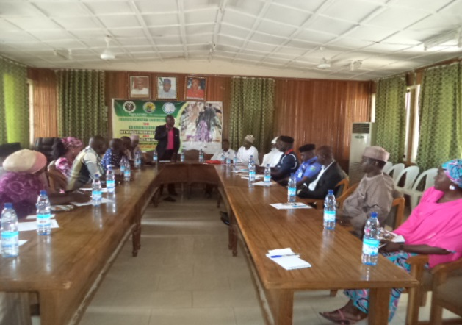
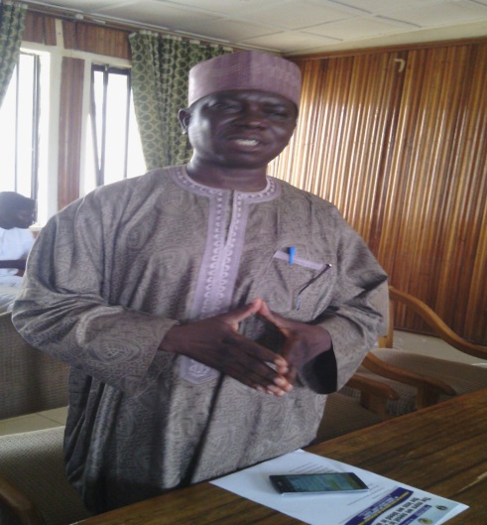
A cross section of participants at the policy dialogue meeting Director of Youth, Ministry of Youth Empowerment Mr. Maxwell
Photos: Cleobas James Wakaye at the event.
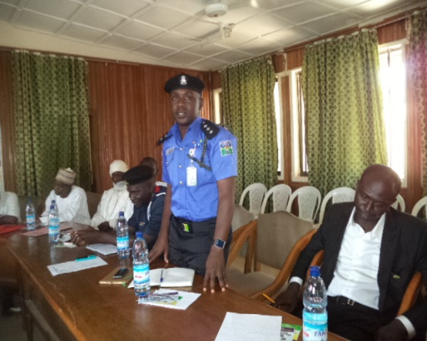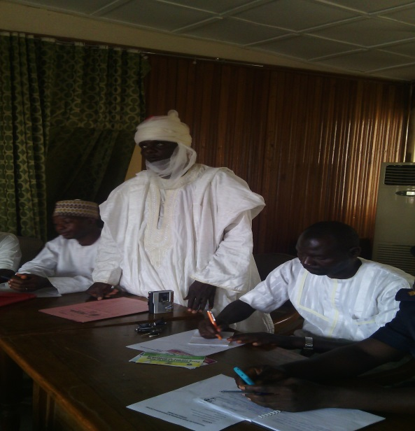
Representative of the CP Gombe State Command, DSP Ahmed Usman. The District head of Pantami
Photos: Cleobas James

Peace sports competitions.
One of the project activities as implemented is a volleyball competitions between security agencies and civilians. The teams that participated in the competition include the Nigeria police volley team, Nigerian Army volleyball team, Labour estate team and Federal low-cost tea.
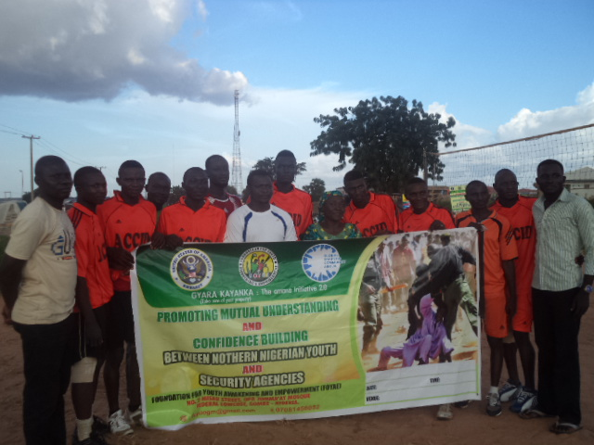
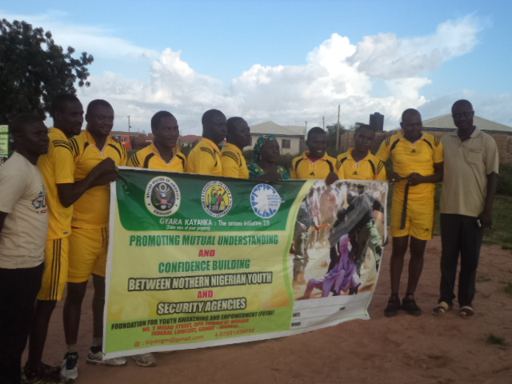
Labour estate team during the finals The Nigeria police team during the finals
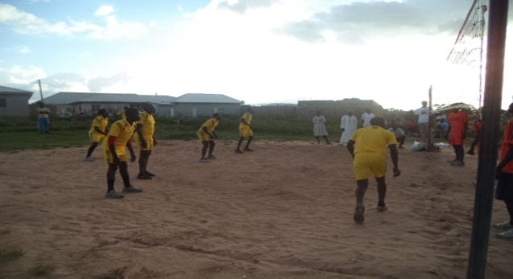
Photos: Cleobas James.
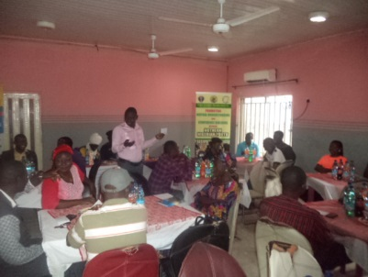
The competition has proved to be another antidote to the frictional relationship between civilians and security. The competition lasted for one (1) week and it was a win – win competition as all participating teams were presented with prizes in order to foster ones. One of the players, a police officer, ASP Ahmed stressed that ‘all of us are youth, the only difference between us is that some wear uniform while others don’t’. He added that the same blood flows through the veins of all persons, as such called for understanding of roles, responsibilities and limitations. The Executive Director, FOYAE who presented prizes to the teams during the finals also called for understanding between civilians and security agencies stressing that only can guaranty peace in our communities. Again, participants appreciated the initiative and called sustainability.
‘DINE WITH A COP’ peace building dinner.
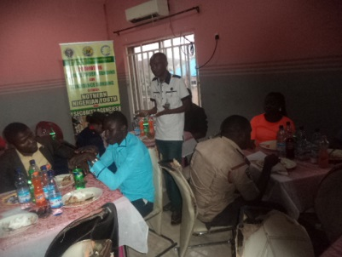
The project ended with a dinner tagged ‘DINE WITH A COP’. The dinner attracted forty eight (48) participants including The police, NCSDC, SSS, traditional leaders, Association of Okada riders, Vigilante, Man ‘O’ War, Gombe state Agency for Social Change, Ministry of Youth Empowerment, FRSC, the media, Civil Society and other youth groups. The dinner further provided an avenue for the target beneficiaries to interact in a more relaxed manner. The need for peaceful coexistence between youth and security agencies was re-echoed and further strengthened. Youth and security agents ate on same table and interacted. They issues of the need for both do abide by the law was raised by the district head of Bolari. He said ‘if said if everybody submits himself to the dictates of the law, we will all live peacefully’. He called on the security agencies to discharge their duties without fear or favour and within the confines of the law. He also called on the youth to be obedient to the constituted authority and conduct themselves peacefully. He said peaceful co-existence is a collective responsibility
Successes
The project has achieved tremendous successes. Notably among them are;
- A state level advocacy committee was formed which will consolidate on the some of the advocacies done by the project team.
- During the stakeholders’ inception meeting it was observed that the initiative of the commissioner of police to reform rampaging youth is commendable but the committee needs to include youth. The CP responded days after the event by including youth in the committee.
- The project has also helped in building mutual understanding among security agencies themselves by bringing them together to interact.
- The National Youth Council, Gombe state chapter, having participated in all activities of the project has concluded plans to replicate some activities of the project, especially the monthly peace road walk.
Lessons learned
- Collaboration is a veritable tool for project success.
- Most Youth and even some security personnel are ignorant of their responsibilities, roles and limitations when it comes to discharging their duties.
- Involving relevant stakeholders in planning and executive of project activities encourages buy-in, ownership and facilitates sustainability.

